American Legion Post 310
Kirklin, Indiana
Procedure Manual
Heating, Ventilation and Air Conditioning System

Contacts

Event | Contact | Phone # | Notes
Ethyl Mercaptan Odor | Fire Dept non-emergency | 765-279-8094 | Have propane detector
Furnace Repairs | Jay’s Heating & Cooling | 765-601-1451 | Jim’s provide services
Propane Tank Filling | Newell Gas & Appliances | 765-249-2866 | Propane supply vendor
Suspected Propane Leak | Forbush Plumbing | 317-768-6423 | Has detector to Locate leak

Procedures
Operation of the Heating and Air Conditioning system is under the Bar Tender’s control at all time. Patrons are discouraged from changing thermostat temperatures, or operating propane control valves without Bar Tender permission.
It is recommended that minimum nominal 20 inch by 20 inch by 2-inch-deep furnace filters, be changed quarterly in the Months of:
- December
- March
- June
- September
To be monitored by Bar Manager and House Committee volunteers.
In event of propane odorant detection, the following shall actions be shall be implemented:
- House Committed members and Bar Manager to be notified by text message what actions has been taken.
- Shut down the propane system at the 500-gallon propane tank located south of the Legion building with the valve nearest the tank on the manifold under the cover.
- Verify the Propane Tank is not near empty. Very low levels of propane increase the odor percentage, making very small releases detectible by the nose.
- Contact the Legion Commander with details of the situation.
- If the odor persists after the valve closing call the non-emergency line of the Kirklin Fire Department appraising the propane odorant has been detected and non-emergency assistance requested to appraise level if importance.
- Newell is very responsive to suspected propane leaks and will provide leak down services on the propane piping system. At the propane tank, will add gages to the piping system the pressurize, then watch for pressure reduction that indicates leakage.
Note: Our system did not leak when the test was completed on Jenaury 3, 2025.
- Calling of Jim’s Heating & Cooling or Hoppy Forbush’s services should be handled by Bar Manager or House Committee member.

Furnace Location
The heating and ventilation systems consist of two Gibson 90,000 btu/hr furnaces installed in September 2012 in the furnace room.
- The north Furnace is for the bar section of the building
- The South Furnace is for the Back-Room area of the building.
Thermostats are Located as Follows:
- Bar area thermostat is located south of the bar on wall separating the men’s room. It is a programable unit.
- Back-Room thermostat is located in the center of the north wall. It is a manual unit.
Propane System and Control Valve Locations
- The 500-gallon propane tank is located on the property south of the Legion building.
The tank is owned and maintained by Newell Gas and Appliances who automatically fill as needed based on degree day estimates, and future monitoring services.
Due to recent (Dec 2025 to Jan 2026) cold weather and increased use of Back-Room the tank emptied on January 3, 2026. Newell is to install a monitoring system to prevent a recurrence.
Note: The 1000-gallon propane tank to the southeast supplies the Post Office.
Emergency Shut Down of propane System
- Location under the lid of the propane tank is valving pictured below
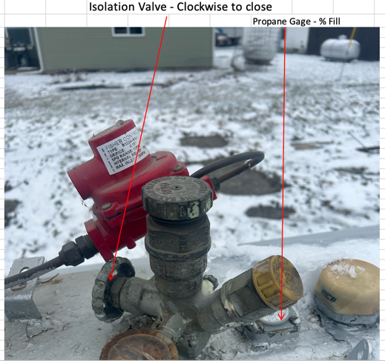

- To shut down the propane system in event the ethyl mercaptan odorant is detected, use the Isolation valve located on the propane tank, by turning clockwise until closed.
Note: The percent level of propane can be determined with the gage. Amount is indicated as a percentage of the tank fill. Maximum fill is around 80% or 400 gallons, leaving a vapor area for expansion of the liquid, as the temperature rises.
- To shut down the individual furnaces use the ball valve on the gas line dripping through the ceiling above to the individual furnaces. Handles parallel to the gas line when open and perpendicular (at 90 degree angle) to the gas line when closed.
Propane Piping System
- The Propane Tank located South of the Legion Building.
- Under the cover protecting the manifold system from sun exposure and physical damage, under the manifold is the isolation valve.
- Piping of propane at higher pressure is underground from the tank to the East wall of the Legion building.
- About 20 ft North of the Storage Building on the East wall the piping rises to a regulator then to schedule 40 piping where it enters the attic area of the back room to the furnace room.
- From the attic individual rubber covered corrugated stainless-steel lines drop to each furnace.
- At each furnace there is a ball type isolation valve. Normally open the handle is parallel to the gas line. Closed the valve is perpendicular to the gas line.
Appendix
House committee Members
Legion Commander | Darryl Shoe | 765-652-2634
Legion Member | Bill Lantrip | 317-201-0500
Legion Member | Loyd Bonecutter | 708-508-2966
Sons’s of Legion Member | Gary Jobe | 317-690-7319
Son’s of Legion Member | Hoppy Forbush | 317-446-2307
Auxiliary Member | Joni Houghton | 317-771-0657
Auxiliary Member | Ky Lockard | 317-956-2388

